**Hotel management system**

**Minor project report**

Submitted in partial fulfilment of the requirements for the award of the degree of

BACHELOR OF ENGINEERING

IN

MECHANICAL ENGINEERING

TECH BOYS( OPERATION BLACK)

BY

GOUTHAM BASKER LALITH ADITHYAA.S

ROLL NO: 111722106007 ROLL NO: 111722106012

AKASH AJAY NAIR

ROLL NO: 111722106002

GUIDED BY

DR. SATHIAMOORTHY.J

ASSOCIATE PROFESSOR

**INTRODUCTION**

1. **Introduction**

Today Developers around the world are making efforts to enhance user experience of using application as well as to enhance the developer’s work flow of designing applications to deliver project’s and rollout change requests and strict timeline. Stacks can be used to build web applications in the shortest span of time. The stacks used in the web development are basically the response of software engineers to current demands. They have essentially adopted pre-existing frameworks to make their lives easier.

* 1. **PURPOSE**

This Hotel Management System Software Requirement Specification (SRS) main objective is to provide a base for the foundation of the project. It gives a comprehensive view of how the system is supposed to work and what is to be expected by the end users. Client’s expectation and requirements are analysed to produce specific unambiguous functional and non-functional requirements, so they can be used by development team with clear understanding to build a system

as per end user needs. This SRS for HMS can also be used for future as basis for detailed understanding on how project

was started. It provides a blueprint to upcoming new developers and maintenance teams to assist

in maintaining and modifying this project as per required changeability

1. In this world of growing technologies everything has been computerized. With large number of
2. work opportunities the Human workforce has increased. Thus there is a need of a system which
3. can handle the data of such a large number of Employees in an organization. This project
4. simplifies the task of maintain records because of its user friendly

1.2 Scope of the Project

The HMS project is intended for the reservations for room that can be made through online. It will be able to automate the various operations of the Hotel. Our Hotel Management System will have three end users: Customer, Receptionist, and Hotel Manager. Hotel Management System will consist of Booking Management System, DBMS Server, and Report Generator. Customers will be able to check for room’s availability, select the rooms, and pay for the room. Receptionist will have access to update or modify booking details. Manager will able to view the financial report and able to update room information such as cost and category. The main goal of this introduced automated HMS software is to simplify every day process of hotel. Day to day Hotels are increasing and they need to automate to provide customer ease of access. It will be able to take care of services to customer in a quick manner. This automation will be able to replace the drawbacks of large customer information physical files which were difficult to handle. Secure Transaction, quick retrieval of information, ease of use, quick recovery of errors, fault tolerance are some of the benefits that development team will be working on to achieve end user satisfaction.

1.3 Overview

The remaining sections of this documentations describes the overall descriptions which includes product perspective and functions, characteristics of users. It also consists of Assumptions, and Constraints. Overall description is listed in section 2. Section 3 includes Specific Requirements which consists of Functional and Non-functional requirements, External Interface Requirements, Software System Attributes, Performance Requirements, Capacity Requirements, Availability Requirements, Safety Requirements and Requirement Traceability Matrix.

2.0 Product perspective

This system here is developed to book room by customers and sending information of customers to recipients and checking the availability of rooms. the customer can see the vacant room information and the cost of booking the room. Manager can view any report such as financial report, customer information, booking information, and room information, analyse them and take the decision accordingly.

2.2 Product Functions

Our Product General functions are:

* Customer Registration
* Check for Availability of Rooms
* Display the Rate
* Confirmation Of Booking
* Email Notification
* Payment
* Set Room Details
* Manage Booking Details
* Generate Report
* Customer Service

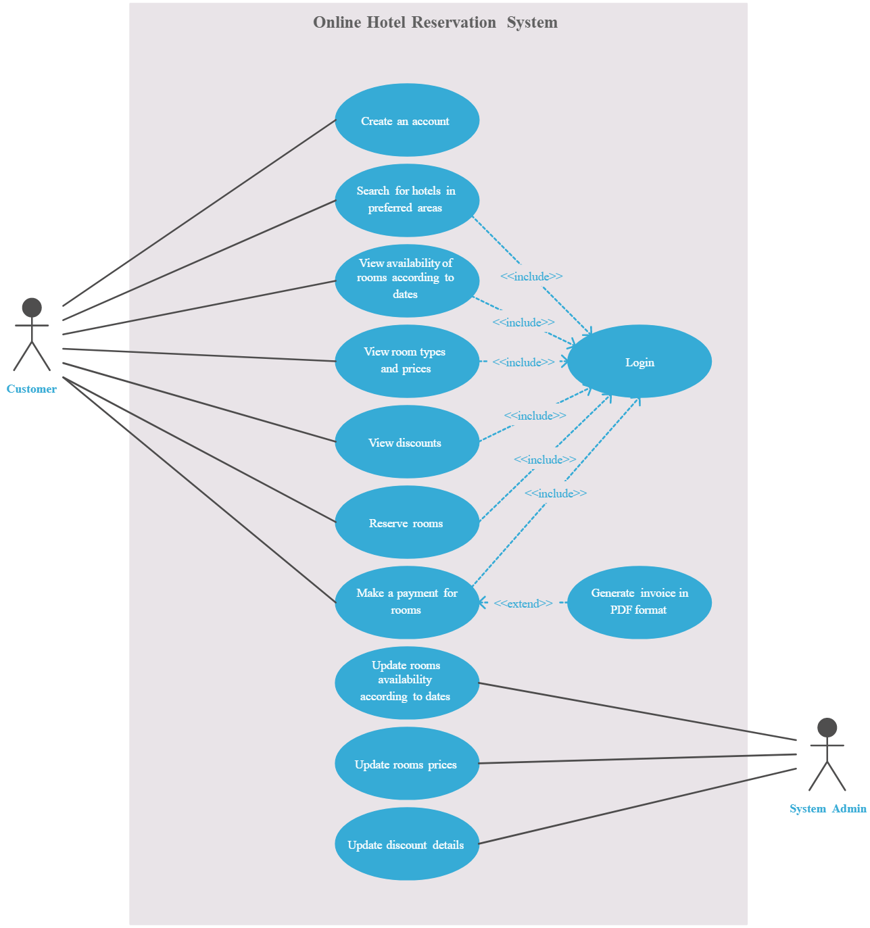

2.3 Constraints

I. Memory: System will have only 10GB space of data server.

II. Language Requirement: Software must be only in English.

III. Budget Constraint: Due to limited budget, HMS is intended to very simple and just for basic functionalities. UI is going to be very simple.

IV. Implementation Constraint: Application should be based on Java only.

V. Reliability Requirements: System should sync frequently to backup server in order to avoid the data loss during failure, so it can be recovered

2.4 Assumption and Dependencies

It is assumed that system developed will work perfectly that’s going to be developed under the Windows OS, and Apache Server with Mongo DB database. If in case of any difficulties, SRS should be flexible enough to change accordingly.